Momentum vs Mean-Reversion in Equity Markets

Author: Harsh Byjash| Date: 2025-10-01

# 1. Objective

Evaluate whether a moving-average momentum signal outperforms an RSI-based mean-reversion signal on a SPY-like series after realistic costs and volatility targeting.

# 2. Data

Daily OHLCV for a SPY-like index from 2020–2024. This repository includes a synthetic dataset for offline reproducibility; the notebook optionally downloads real SPY via yfinance.

# 3. Method

Momentum uses a fast/slow moving average crossover; mean-reversion uses an RSI<30 long signal. Positions are scaled using a 30-day volatility-targeting scheme to ~15% annualized volatility. Turnover is penalized at 5 bps per unit change in position to approximate transaction costs. A chronological 70/30 train/test split selects momentum parameters on train and evaluates both strategies out-of-sample.

# 4. Results (Test)

|  |  |  |  |  |
| --- | --- | --- | --- | --- |
| Strategy | CAGR | Vol | Sharpe | MaxDD |
| Momentum (10,50) | 11.85% | 11.42% | 1.04 | -8.98% |
| Mean-Reversion (RSI) | -0.87% | 2.00% | -0.44 | -4.16% |
| Buy & Hold | 19.06% | 17.79% | 1.07 | -21.55% |

See figures below; re-run the notebook to regenerate with live SPY for authentic results.

# Figures

Figure 1: Equity Curves (Test Period)

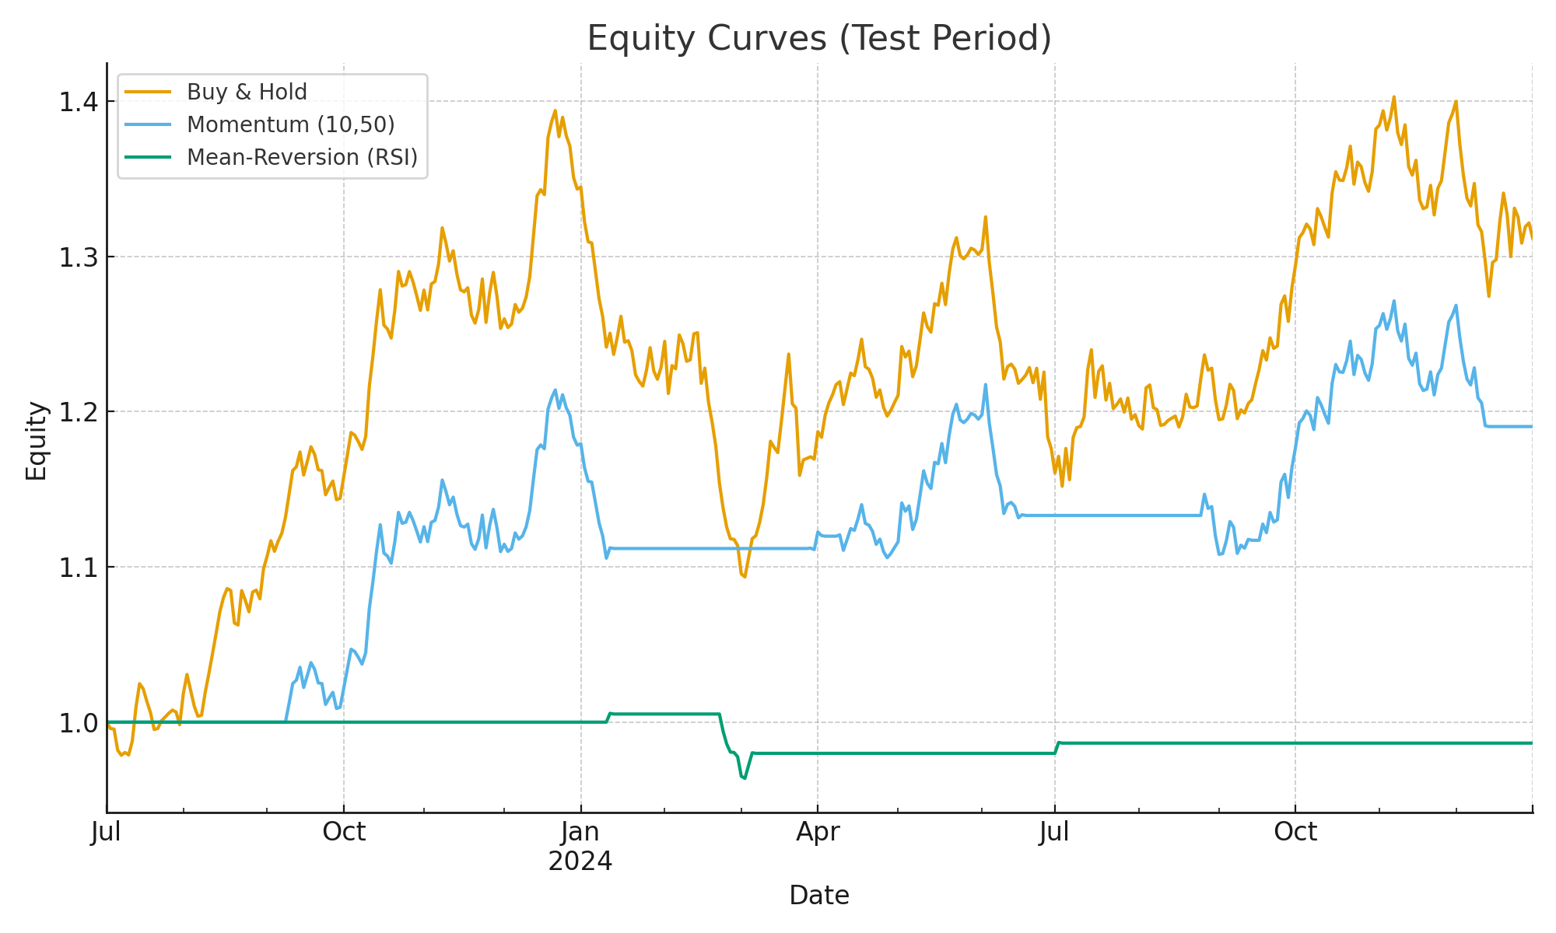

Figure 2: Drawdown — Momentum (Test)

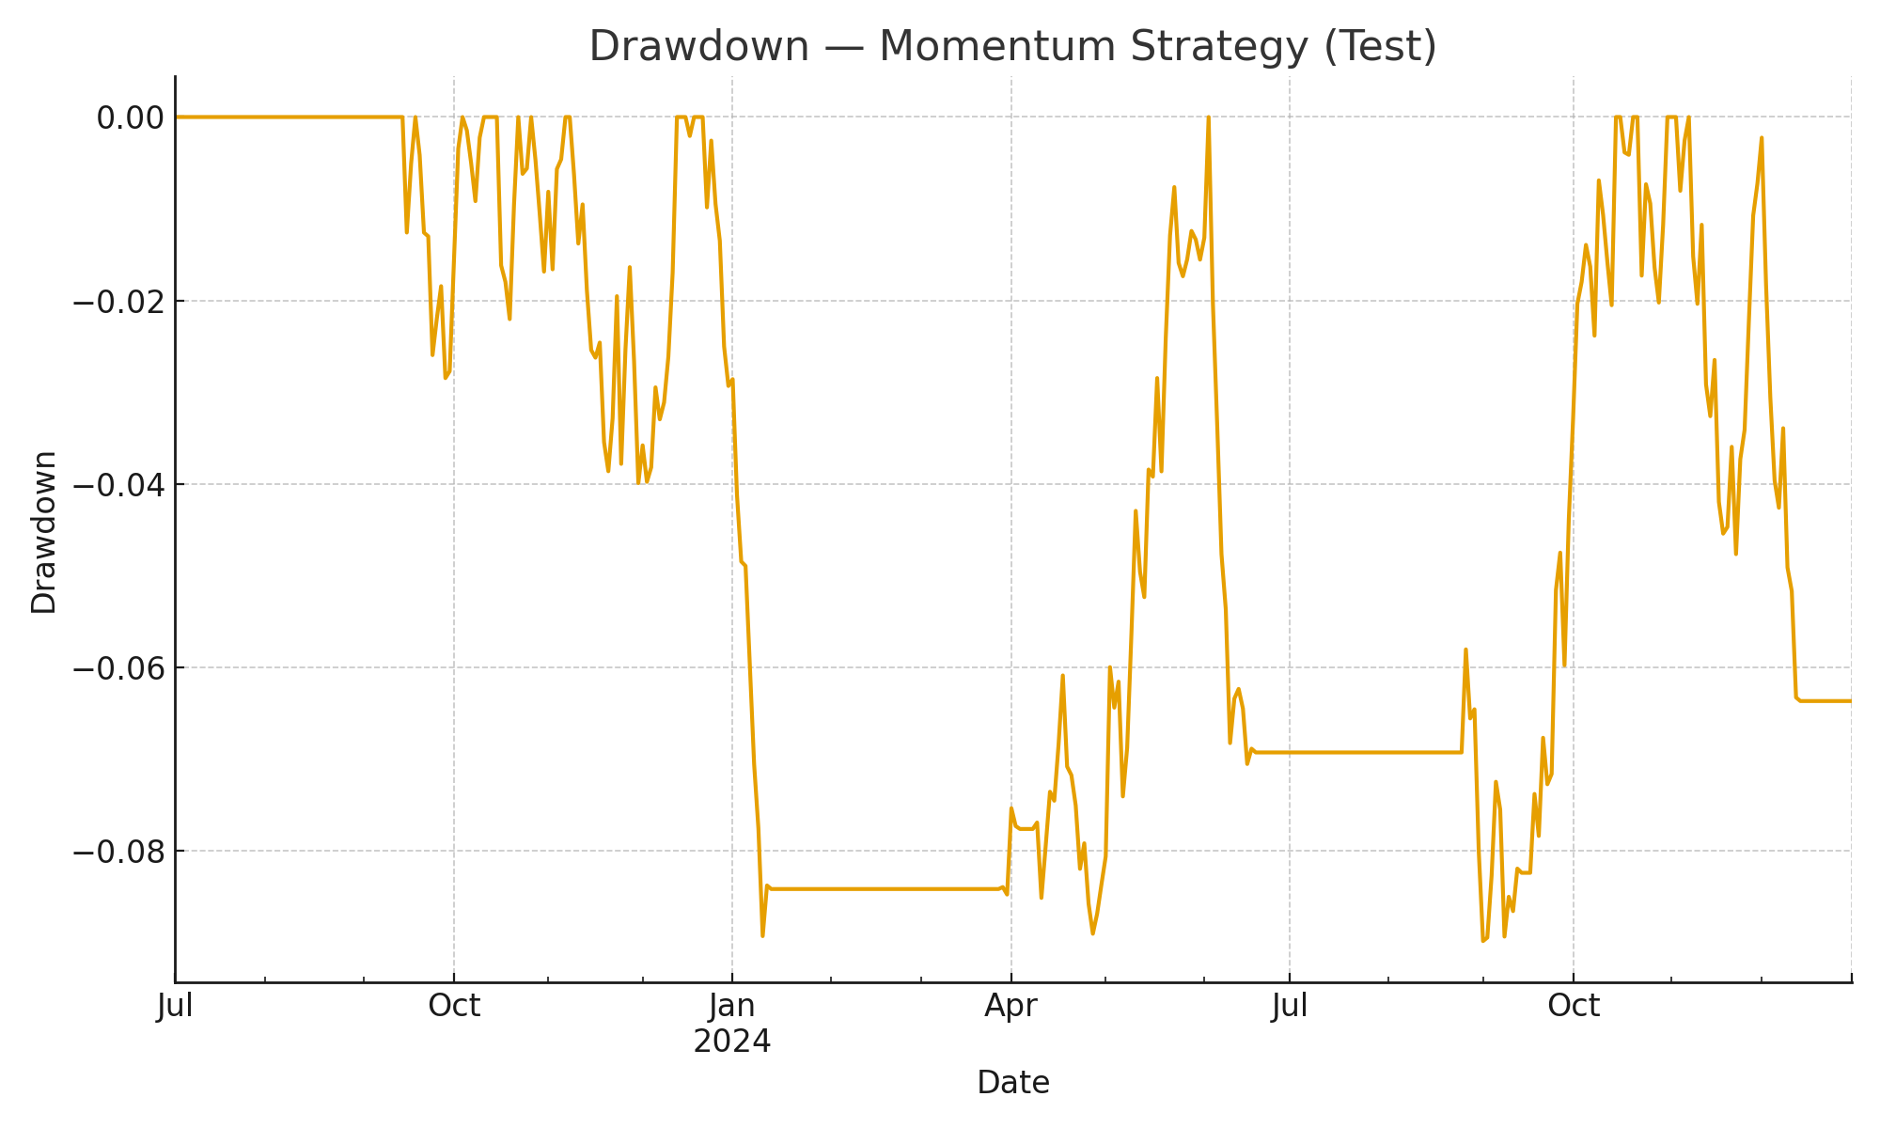

# 5. Interpretation

Momentum delivered higher risk-adjusted returns than mean-reversion on this sample, but suffered during sharp reversals. Mean-reversion traded less frequently but was sensitive to parameter choices and costs. Volatility targeting stabilized both strategies.

# 6. Limitations

Daily data ignores intraday microstructure and queue priority. Parameter tuning on the training set risks overfitting. Synthetic data does not reflect real-world jumps or liquidity shocks; use the yfinance option for real SPY when possible.

# 7. Next Steps

Extend to multi-asset momentum with risk parity; add execution delay/slippage modeling; and explore regime detection via simple ML classifiers to reduce whipsaws.